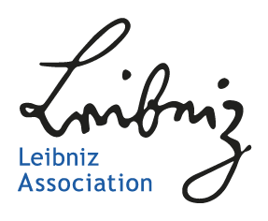

Opinion of the Scientific Advisory Board

Leibniz ScienceCampus

Title

[project number]

Members of the Scientific Advisory Board
Member A (institute, country)
Member B (institute, country)
…

For continuation applications, please provide a short assessment about the first funding phase of the Leibniz ScienceCampus. The report should not exceed a total length of two pages and may comprise an evaluation of
- the implementation of the work programme and the milestones achieved,
- the strategic further development of the work programme and planned objectives,
- collaboration structures and the added academic and strategic value thereby achieved,
- results thus far (publications, theses, third-party funding, etc.),
- prospects for the continuation after a second funding phase.

[Text Arial 11 Pt]

