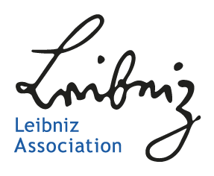

Opinion of the Scientific Advisory Board

Leibniz Research Alliance/ Leibniz ScienceCampus

Title

[project number]

Members of the Scientific Advisory Board
Member A (institute, country)
Member B (institute, country)
…

Please provide a short assessment about the current funding phase of the Leibniz Research Alliance/ Leibniz ScienceCampus, taking into account the respective final report of the Research Alliance/ ScienceCampus. The report should not exceed a total length of two pages and may comprise an evaluation of
- the implementation of the strategic research programme and milestones achieved,
- results in the form of academic publications, theses/dissertations, funding from third parties, academic conferences, public relations and knowledge-transfer measures, patents and other forms where appropriate,
- if applicable, the strategic continuation of the work programme and objectives,
- collaboration structures and the added academic and strategic added value thereby achieved,
- Prospects for continuation after the current funding phase.

[Text Arial 11 Pt]

